**Miami Valley Risk Management Association**

**Presents:**

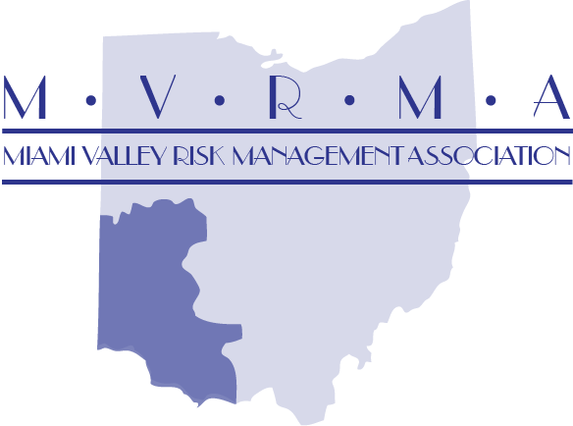

**Managing the Discipline Process Workshop**

**-**

**When: Thursday October 10th, 2019**

**Where: City of Sidney Police, 234 W Court St, Sidney, OH 45365**

**Time: 9:00 am – 3:30pm**

**Cost: $40 for MVRMA, MVCC & CLG Members $60 for non-members**

**Jonathan Downes** has over 30 years of experience in practicing labor and employment law in Ohio and has successfully negotiated over 500 labor agreements and has presented over 100 impasse proceedings and 100 arbitrations. He represents cities, townships, counties, school districts, and public officials throughout the State of Ohio. Jonathan also represents private employers in employment matters. He has argued cases before the Ohio Supreme Court and the United States Court of Appeals for the Sixth Circuit.

He lectures frequently on many topics including state and federal employment and labor law developments, civil rights, civil service, arbitration, and collective bargaining. Jonathan served on the Civil Service Review Commission for the State of Ohio, authored “Civil Service Law in Ohio,” and edits the Westlaw annual publication of the “Ohio Civil Service and Collective Bargaining Laws and Rules Annotated.”



**Course Description:** A comprehensive session on discipline, this session is designed for Chiefs, Human Resources and Law Directors, Administrators/Managers, Supervisors, and others who are responsible for oversight of employee conduct and/or for discipline.  Fundamental process is included and advanced process and practice points are included.   Case examples and citations form the basis of explaining the causes for discipline.

The materials include: the standards of conduct for safety forces and service employee; investigation of discipline; requirements of the pre-disciplinary process; the standards of proof for presenting discipline cases in arbitration and civil service; and the presentation of discipline hearings.   Sample forms are provided.

Topics to be covered include:  Purpose of discipline and progressive discipline; Required employment policies; grounds for discipline; Importance of documentation; Understanding Garrity/Piper and Loudermill hearings; Implications for collective bargaining contracts; special issues, and much more. Case Examples are provided to help highlight the key points.

Please contact Starr Markworth with any questions, [smarkworth@mvrma.com](mailto:smarkworth@mvrma.com) -register through the MVRMA website [www.mvrma.com](http://www.mvrma.com) or through the link below:

[***REGISTER***](http://mvrma.com/index.php/en/training/training-registration)